Planning and Environment Act 1987

HUME PLANNING SCHEME

AMENDMENT C253

EXPLANATORY REPORT

Who is the planning authority?
This amendment has been prepared by the Hume City Council, the planning authority for this proposal, and has been made at the request of the landowner, TF and A Millett Pty Ltd.

Land affected by the amendment
The amendment applies to 105 Vineyard Road, Sunbury, known as Lot 2 PS510978 and part of Lot C PS645987, as shown below:
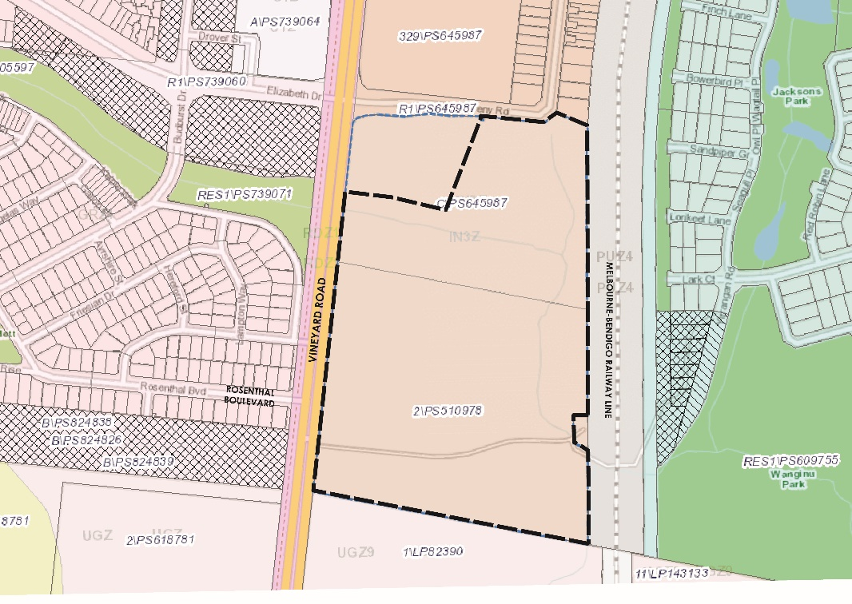
Figure 1: Black dashed line indicates extent of land proposed to be rezoned.

What the amendment does
The amendment seeks to rezone the land from Industrial 3 Zone to the General Residential Zone and apply a Development Plan Overlay Schedule 32. This proposal will facilitate residential development, giving a more suitable interface with the proposed residential development to the south which is part of the Sunbury South Precinct Structure Plan (PSP).
The amendment proposes the following changes to the Hume Planning Scheme:
- Amend Planning Scheme Map No 6 to rezone 105 Vineyard Road to the General Residential Zone (GRZ).
- Amend Planning Scheme Map No 6DPO to include the Development Plan Overlay Schedule 32 on the land.
- Insert a new schedule 32 to Clause 43.04 Development Plan Overlay.
It is noted that the Public Acquisition Overlay, Schedule 2 (PAO2) has recently been removed from the land.

Strategic assessment of the amendment

Why is the amendment required?
The amendment will allow residential land development which follows the strategic direction for the Sunbury Growth Corridor Plan, Sunbury HIGAP Spatial Strategy, Clause 21 of the Hume Planning Scheme and the Sunbury South Precinct Structure Plan (PSP).
The Sunbury HIGAP Spatial Strategy sees the subject site’s future as residential, with the existing Industrial 3 zone to be retained on land to the immediate north of Harpers Creek. This proposal seeks to rezone land south of Harpers Creek. This outcome is consistent with the HIGAP Strategy, which draws its strategic directions from the Growth Corridor Plan, whilst the Sunbury South PSP provides strategic direction for land to the south.
Introducing a Development Plan Overlay for the land will enable development to integrate with the surrounding area.
A good planning outcome will be achieved by enabling:
- Harpers Creek and future stormwater retarding basin as a natural separation between industrial and residential land uses.
- A more effective interface with residential land to the south, as proposed by the Sunbury South PSP.
- Additional residential land within walking distance of the proposed Sunbury South train station, future Neighbourhood Activity Centre (NAC) to the south and the existing Rosenthal Activity Centre to the north/west.
The proposal will achieve a net community benefit by providing:
- Connectivity to existing and future open spaces and activity centres in the area through the provision of a new intersection, connector road and shared paths.
- Opportunities for additional residential development and densities to contribute to the critical mass required for a successful rail precinct.
- Opportunities for housing choice and diversity within Sunbury.
- A contribution towards Affordable Housing in the form of social housing.
- Open space in the form of a local park for the future and existing communities.
- Continuous walking and cycling along Harpers Creek, and on Elizabeth Drive providing a connection to the Rosenthal Activity Centre.
- In addition, provide for the opportunity to connect under the viaduct to open space on the eastern side of the rail line.

How does the amendment implement the objectives of planning in Victoria?
The proposal implements the following objectives of planning in Victoria, set out in Section 4(1) of the Planning and Environment Act 1987:
- (a) to provide for the fair, orderly, economic and sustainable use, and development of land.
- (c) to secure a pleasant, efficient and safe working, living and recreational environment for all Victorians and visitors to Victoria.
- (d) to conserve and enhance those buildings, areas or other places which are of scientific, aesthetic, architectural or historical interest, or otherwise of special cultural value.
- (f) to facilitate development in accordance with the objectives set out in paragraphs (a), (b), (c), (d) and (e).
The proposal will also enable land use and development for residential development, in a location close to existing and future services and in a manner which complements surrounding uses.

How does the amendment address any environmental, social and economic effects?
Environmental
The amendment will have a positive environmental benefit. It will facilitate rehabilitation of Harpers Creek and the protection of cultural and heritage assets in the waterway corridor, including the heritage listed culvert/ railway bridge.
The Harpers Creek corridor will also provide effective separation between industrial uses to the north, and residential uses to the south. This will achieve continuation of Sunbury South PSP residential uses. Further, the creek is proposed to incorporate a stormwater management function also catering for the industrial uses to the north and provide an effective retarding basin.
The site does not present any evidence of land contamination and is suitable for the proposed residential use of the land.
The ecological value of the site is low and does not make a significant contribution to Victoria’s biodiversity, the biodiversity of the site or the surrounding region.
Social
The future community will have ready access to a range of community and built infrastructure and services in the nearby area.
The Sunbury PSP plans for a future NAC and railway station in proximity to the site and provides for a range of community facilities including open spaces, schools and community centres. These amenities are in addition to the existing Rosenthal Activity Centre, and Sunbury Town Centre to the north. The landowner of the site has agreed to contribute towards the establishment of community infrastructure in Sunbury South.
Further, the site itself will provide valued amenity for the future community including open space in the form of a local park along the creek corridor.
Dedicated walking and cycling paths along the creek as well as on Vineyard Road will provide connections to nearby local amenities.
Economic
The Melbourne Industrial and Commercial Land Use Plan (MICLUP), released by the State Government in 2020, identifies sites of state, regional and local significance. The subject land has been identified as locally significant industrial land which means that Council is responsible for identifying when it is no longer required and can transition to alternative uses.

Harpers Creek runs through the site from west to east creating a natural and distinct separation between the employment land to the north and the proposed residential land to the south. The Sunbury HIGAP supported this natural delineation in land use and recognised that the proximity to the future Sunbury South train station and Rosenthal Activity Centre made the area highly suited to residential development.

Does the amendment address relevant bushfire risk?
The land is in a designated bushfire prone area but is not included in the Bushfire Management Overlay (BMO). The site is bounded on all sides by current and future growth areas, meaning that the area will change significantly over the coming years as land develops. Key considerations the development will take into account:
- Designing the subdivision to manage bushfire risk; and
- Establishing a buffer between the bushfire hazard and urban development through subdivision design.
As development of the land progresses, bushfire risk will be further diminished and managed to ensure there will be a reduction in bushfire risk overall in the area.
Comments from the Country Fire Authority (CFA) will be sought as part of the Amendment’s statutory exhibition.

Does the amendment comply with the requirements of any Minister’s Direction applicable to the amendment?
The amendment complies with the requirements of the Ministerial Direction -The Form and Content of Planning Schemes.
The following Minister’s Directions are also relevant to this proposal:
Direction No. 1 Potentially Contaminated Land
Under Ministerial Direction No 1, the planning authority must satisfy itself that the environmental conditions of the subject site are or will be suitable for residential land use.
The Preliminary Site Investigation completed by Ground Science (May 2017) submitted as part of the request to rezone the land concludes that the site is considered suitable for the proposed residential land use and no further investigation is recommended.
Direction No. 9 Metropolitan Planning Strategy
The amendment must have regard to the Metropolitan Planning Strategy - Plan Melbourne 2017-2050. The Melbourne 2050 Plan identifies the site within an ‘urban area’ with rail improvements between Sunbury and Melbourne located adjacent to the site.
The amendment achieves the following objectives of Plan Melbourne:
- Direction 2.1 - Manage the supply of new housing in the right locations to meet population growth and create a sustainable city.
- Direction 2.2 - Deliver more housing closer to jobs and public transport.
- Direction 2.3 - Increase the supply of social and affordable housing.
- Direction 2.5 - Provide greater choice and diversity of housing.
- Direction 5.1 - Create a city of 20-minute neighbourhoods.
- Direction 5.2 - Create neighbourhoods that support safe communities and healthy lifestyles.
- Direction 5.4 - Deliver local parks and green neighbourhoods in collaboration with communities.
- Direction 6.3 - Integrate urban development and water cycle management to support a resilient and liveable city.
The proposal’s preparation has been consistent with the Minister’s Direction No. 11 Strategic Assessment of Amendments. The proposal’s progress is intended to meet the required time frames set out in the Minister’s Direction No. 15 The Planning Scheme Amendment Process.

How does the amendment support or implement the Planning Policy Framework and any adopted State policy?
The proposed amendment is consistent with the objectives of Planning Policy Framework (PPF) and will assist in achieving objectives in relation to the following Clauses:
Plan Melbourne
As detailed above, the proposal is consistent with the objectives in Plan Melbourne 2017- 2050.
Clause 11 Settlement
Clause 11.01-1S Settlement of the PPF sets out to promote the sustainable growth and development of Victoria. It focusses on creating a network of settlements that are connected and sustainably planned in accordance with relevant regional growth plans. In the context of Sunbury, this means that they are planned in accordance with Plan Melbourne and the Sunbury Growth Corridor Plan.
Clause 11.02-1S Supply of urban land ensures that there is at least a 15-year supply of land to accommodate projected population growth, to support sustainable urban development. Also, Clause 11.02-3S Sequencing of development ensures that services are available to new communities, and that development makes a financial contribution towards infrastructure provision.
11.03-2S Growth areas encourages new development to be located close to transport corridors and services and be provided efficient and effective infrastructure. This clause also encourages overall residential densities of a minimum of 15 dwellings per net developable hectares increasing to 20 dwellings per net developable hectare over time. The site provides for residential development in proximity to a proposed train station, supporting allowing for a mix of densities to be achieved.
Clause 12 Environmental and Landscape Values
Clause 12.03-1S River corridors, waterways, lakes and wetlands seeks to protect and enhance these features. The clause seeks to ensure that development responds to and respects and enhances the cultural, environmental and landscape values of waterways. Harpers Creek will be enhanced as part of the development.
Clause 13 Environmental Risks and Amenity
Clause 13.02-1S Bushfire Planning seeks to ensure that the resilience of settlements to bushfire is managed through risk-based planning that prioritises the protection of human life. The clause ensures that planning scheme amendments properly assess bushfire risk and include appropriate bushfire protection measures. It is noted that the subject land is within a Bushfire Prone area.
Clause 13.03-1S Floodplain Management protects the flood storage function of rivers and waterways.
A retarding basin will be constructed on the site to manage stormwater and the outlet to Harpers Creek will be approved by Melbourne Water to protect the floodplain from both this and adjoining development.
Clause 13.04-1S Contaminated and potentially contaminated land seeks to ensure that potentially contaminated land is suitable for its intended future use and development, and that contaminated land is used safely. Site investigations have addressed this clause and the site is safe for its future use.

Clause 13.01-1S Noise Abatement seeks to assist the control of noise effects on sensitive land uses.

Potential noise impacts from the adjoining railway will be identified and subsequently managed by requiring an acoustic report to be submitted as part of any development application for any noise affected areas. The acoustic report must consider the Victorian Passenger Rail Infrastructure Policy 2013 and address its recommendations for noise attenuation.

Clause 15 Built Environment and Heritage
Clause 15.01-1S Urban Design seeks to create urban environments that are safe, functional and provide good quality environments with a sense of place and cultural identity. Clause 15.01-3S Subdivision Design seeks to ensure the design of subdivisions achieves attractive, liveable, walkable, cyclable, diverse and sustainable neighbourhoods. Also, Clause 15.01-4S Healthy Neighbourhoods seeks to ensure neighbourhoods foster healthy and active living and community wellbeing. Clause 15.01-4R also includes the strategy to create a city of 20-minute neighbourhoods that give people the ability to meet most of their everyday needs within a 20-minute walk, cycle or local public transport trip from their home.
The site is proximate to the proposed Sunbury South train station and future Neighbourhood Activity Centre. It is also close to the existing Rosenthal Activity Centre to the north-west and has frontage onto Vineyard Road, where there are regular bus services which connect Sunbury to Melbourne’s northern suburbs.
Clause 15.03-2S Aboriginal Cultural Heritage seeks to ensure the protection and conservation of places of Aboriginal cultural significance. Aboriginal cultural heritage will be protected within the Harpers Creek corridor.
Clause 16 Housing
Clause 16.01-2S Location of residential development seeks to locate new housing in locations that offer good access to jobs, services and transport. Clause 16.01-3S and R Housing diversity encourages a range of housing types to meet diverse needs. Clause 16.01-4S Housing affordability seeks to deliver more affordable housing closer to jobs, transport and services. The proposed schedule to the Development Plan Overlay ensures the area will provide for housing diversity as well as provide some affordable housing as agreed. This diversity will include opportunities for medium density housing.
Clause 19 Infrastructure
Clause 19.02-6S and 6R Open Space and Open Space – Metropolitan Melbourne seeks to encourage a network of open spaces that meets the needs of the community. Open Spaces need to be linked and provide walking and cycling trails. Clause 19.03—1S Development and infrastructure contribution plans discusses development infrastructure and identifies the need to facilitate the timely provision of planned infrastructure, and for utilities to be provided in a timely manner. Clause 19.03-2S Infrastructure design and provision seeks to ensure that infrastructure is proposed in a timely, efficient and cost-effective way to new communities. Clause 19.03-3S Integrated Water Management seeks to sustainably manage water supply, water resources, wastewater, drainage and stormwater through an integrated water management approach. The Development Plan Overlay schedule addresses infrastructure planning and provision to meet the objectives and strategies of these clauses.
As the land sits outside an Urban Growth Zone and is therefore not included within a PSP, a development plan provides an appropriate planning tool to ensure the objectives of Clause 11.03-2S will be met.

How does the amendment support or implement the Local Planning Policy Framework, and specifically the Municipal Strategic Statement?
Municipal Strategic Statement
Clause 21.01-1 outlines Hume’s Vision and Strategic Framework Plan. The HIGAP plan for Sunbury 2040 states the vision for Sunbury. The proposed amendment implements the vision by:
- Providing diverse housing opportunities located close to facilities.
- Protecting cultural heritage.
- Providing public space and continuous access along waterway corridors.
Clause 21.02 Urban Structure and Settlement provides reference to the Sunbury HIGAP Strategy as providing the long-term strategy for the Sunbury growth area.
Clause 21.02-3 Sunbury includes key objectives set to meet the Vision outlined in 21.01-3. The amendment meets these objectives by:
- Improving the transport network to better connect different areas of Sunbury; and
- Facilitating new residential areas that are supported by a network of activity centres and higher order facilities.
Clause 21.03 Liveable Neighbourhoods and Housing seeks to ensure that infrastructure is provided to communities to a high standard and in sequence with development. This is met by providing opportunities for a diverse range of housing in proximity to facilities, and with infrastructure provided from the commencement of development.
Clause 21.04 Built Environment and Heritage encourages new growth areas to ensure that from commencement the design and layout of new areas is of high quality and achieves the best urban design outcomes. Key objectives that the amendment meets include:
- High quality development adjacent to or visible from major roads and key transport routes;
- Ensuring development addresses the street and provides an active interface to the public realm, including open space and creek corridors;
- Maintaining boulevard treatments along the entire length of Vineyard Road;
- Providing a continuous and connected open space network; and
- Ensuring open spaces have street frontages and provide walking and cycling routes.
Local Planning Policies
There are no Local Planning Policies considered relevant to this amendment request. Local controls will be implemented through the proposed Development Plan Overlay.

Does the amendment make proper use of the Victoria Planning Provisions?
The amendment meets the form and content requirements of the Victoria Planning Provisions. The application of the General Residential Zone and a Development Plan Overlay are considered the most appropriate tool to apply to the site to guide its future use and development.

How does the amendment address the views of any relevant agency?
The specific views of select agencies have been sought and are incorporated into this amendment. In particular:
- Melbourne Water has been consulted regarding the Harpers Creek corridor, and the plan included in the proposed Development Plan Overlay schedule accords with the agreed design requirements for the waterway corridor.
- Department of Transport for Victoria has been consulted regarding road and public transport matters, and the location of the intersection and connector streets have been agreed, and the interface with the railway corridor has been addressed in the schedule to the DPO.
- The Environment Protection Authority (EPA) have been consulted regarding the transition of the land from industrial to residential.
Other agencies have not been specifically consulted at this time on this amendment.
Relevant agencies will also have an opportunity to provide their views on this amendment as part of the Amendment’s statutory exhibition.

Does the amendment address relevant requirements of the Transport Integration Act 2010?
Council is considered an ‘interface body’ under Section 25 of the Transport Integration Act 2010. An interface body must have regard to the transport system objectives and the decision-making principles of the Transport Integration Act when performing its functions under any interface legislation (including the Planning & Environment Act, 1987) which are likely to have a significant impact on the transport system. The proposed amendment ensures transport and land use planning are integrated and appropriate transport infrastructure outcomes are provided for.

Resource and administrative costs

What impact will the new planning provisions have on the resource and administrative costs of the responsible authority?
The amendment will have minimum impact on the resources and administrative costs of the responsible authority.

Where you may inspect this amendment
The amendment can be inspected free of charge at the Hume City Council website at www.hume.vic.gov.au
and
The amendment is available for public inspection, free of charge, during office hours at the following places (Covid 19 lockdown restrictions observed):

- Broadmeadows Customer Service Centre at 1079 Pascoe Vale Road, Broadmeadows
- Hume Global Centre Craigieburn at 75-95 Central Park Avenue, Craigieburn
- Hume Global Learning Centre Sunbury at 44 Macedon Street, Sunbury
The amendment can also be inspected free of charge at the Department of Environment, Land, Water and Planning website at www.planning.vic.gov.au/public-inspection.

Submissions
Any person who may be affected by the amendment may make a submission to the planning authority. Submissions about the amendment must be received by Monday, 8 November 2021.
A submission must be sent to:
Hume City Council,
PO Box 119, Dallas, 3047 or via email to:
contactus@hume.vic.gov.au

Panel hearing dates
In accordance with clause 4(2) of Ministerial Direction No.15 the following panel hearing dates have been set for this amendment:
- directions hearing: in the week commencing Monday, 31 January 2022
- panel hearing: in the week commencing, Monday, 28 February 2022

